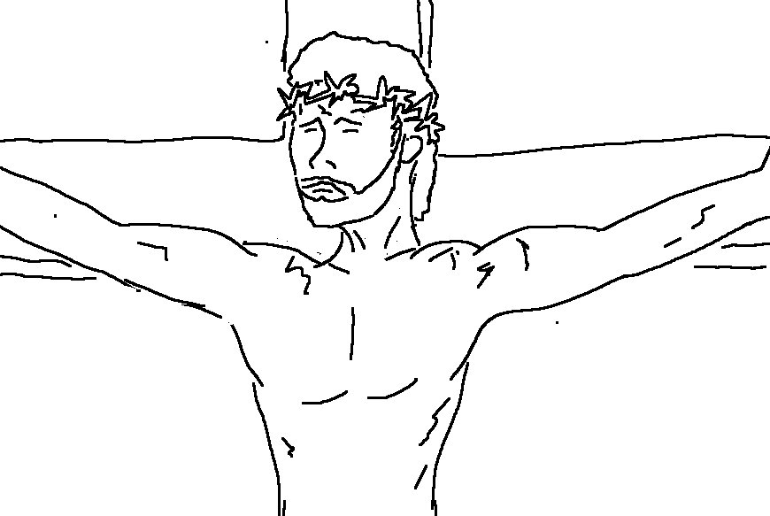
Look! The _ _ _ _ of _ _ _ who takes away the _ _ _ of the world!
John 1:29_{NLT}

